Extra Practice Sample Answers
Extra Practice 1 – Master 2.18

Lesson 2.1
1. a) –12
b) Adding a number 4 times is the same as 4 times the number.
2. a) +12
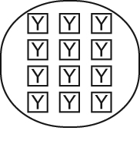
b) –42
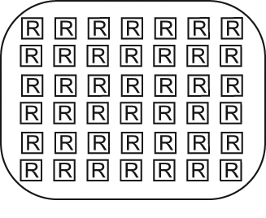
c) –15
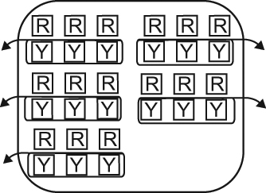

d) +24
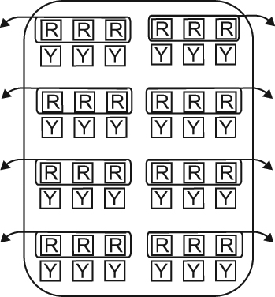

3. a) +16
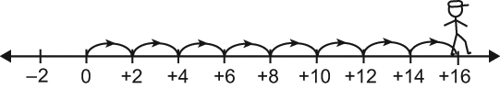

b) –12
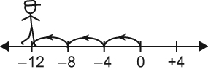

c) –36
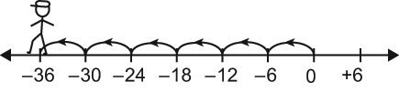

d) +18
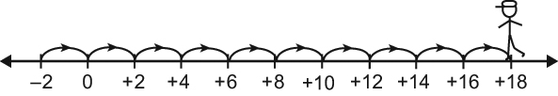
4. (+5) × (–2) = –10; the ice melted 10 cm after 5 days.
5. a) (+2) × (–30) = –60; Aliya is 60 cm below her previous elevation.
b) (–3) × (–30) = 90; Aliya was 90 cm above her current elevation.

Extra Practice 2 – Master 2.19
Lesson 2.2
1. a) +4; 0; –4; –8;
(+4) × (–3) = –12
(+4) × (–4) = –16
(+4) × (–5) = –20
b) +5; 0; –5; –10;
(–3) × (+5) = –15
(–4) × (+5) = –20
(–5) × (+5) = –25
2. a) The product of two integers is positive when the integers have the same sign.
b) The product of two integers is negative when the integers have opposite signs.
3. a) –18 b) +12
c) –14 d) –12
e) –1 f) +25
4. a) +330 b) –860
c) +918 d) –682
e) –1206 f) 1612
5. a) +3 and +6; the greatest product will be a product of two numbers with the same sign and largest size. So, it will be (+3) × (+6) = +18 or (–2) × (–8) = +16.
b) +6 and –8; the least product will be a product of two numbers with opposite signs and largest size. So, it will be (+6) × (–8) = –48.

